TITLE OF THE PAPER SHOULD BE IN UPPER CASE
14 POINT TIMES NEW ROMAN BOLD FONT

Naoto Kasahara¹, Naoki Miura²

¹ Professor, The University of Tokyo, Tokyo, Japan (name@email.com)
² Research Scientist, Central Research Institute of Electric Power Industry, Kanagawa, Japan

INTRODUCTION

Please read carefully all the instructions given below and follow the instructions exactly when you prepare your manuscript to insure uniformity in the appearance of the papers in the conference proceedings. The provided template follows the required format, and it is strongly recommended to use it as a starting point for your paper. The complete manuscript (full text and figures) should be submitted as a PDF file.

Contributions are accepted on the understanding that the paper is original and has not been published before. By submitting your manuscript, the Lead Author, with the consent of all co-authors, agree to the copyright transfer agreement.

Please note that you can only submit your paper after you have been notified of abstract approval. Please submit your paper via confit system. Information on how to submit the full paper will be announced at the beginning of in September.

LANGUAGE

All papers must be written in English.

PAPER LENGTH

The maximum number of pages allowed for each paper is 10 including references. This number includes title, abstract, text, figures, tables, references, and appendices. Manuscripts longer than the assigned number of pages may not be accepted.

PAGE LAYOUT

Use “letter” sized paper (page size 8-1/2” x 11”), with 1” margins all around.

HEADER AND FOOTER

Please use the headers provided in this template. Include the assigned division number for the paper in the header of the first page, as well as the header of the following pages, as shown. Do not include page numbers in the header or footer. The footer should be left blank.

ABSTRACT

An abstract should follow the author information on the first page. The word “ABSTRACT” is followed by the abstract text which outlines the aim, scope, and main conclusions of the presented work. The abstract should be concise.

PARAGRAPH AND FONT

All papers must use 11-point Times New Roman font with single line spacing, except using 14-point Times New Roman for the title of the paper as shown in this template. All paragraphs should be single column and justified.

The first paragraph in every section should NOT be indented. All other paragraphs should be indented 0.5 inches (12.7 mm).

PRIMARY HEADINGS

All headings should be positioned flush left. Headings should be presented as shown in this template, where primary headings are written in upper case bold with one blank line above and below the heading.

Secondary Headings

Secondary Headings should be written in italic bold font, and the first characters of all words in a secondary heading should be written in upper case with one blank line above and below the heading.

FIGURES, TABLES AND EQUATIONS

Centre table title above the table and figure caption below the figure. Allow one line of space between the table title and table and between the figure and its caption. Allow one line of space between the table, table title, figure or figure caption and the adjacent text. Tables and figures may be in colour.

Figures, equations, and tables should be included in the text and numbered sequentially. For example:
Table 1: Tables should be centred and preceded by a numbered caption.

 | P-1 | P-2 | P-3 | P-4 | P-5
D_{o Flank-Flank} [m] | 2.384 | 2.393 | 2.408 | 2.424 | 2.378
t – Flank [m] | 0.196 | 0.223 | 0.224 | 0.224 | 0.207
V– Flank [m/sec] | 0.241 | 0.228 | 0.226 | 0.225 | 0.233
D_{o Intra-Extra} [m] | 2.358 | 2.270 | 2.274 | 2.303 | 2.379
t – Intrados [m] | 0.243 | 0.281 | 0.293 | 0.282 | 0.200
t – Extrados [m] | 0.204 | 0.199 | 0.202 | 0.205 | 0.217

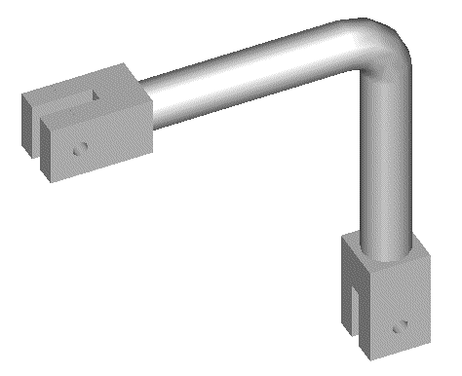

Figure 1. Figures should be centred and followed by a numbered caption.

Equations should be centred and numbered in parentheses. The equation number should be positioned flush right. Equations should be referred to in the text as in the following example. See Equation 1 below:

$∆d= A (∆{δ_{p})}^{a}$ (1)

Where $∆d$ is the rate of deterioration per reversal, $A$ and $a$ are parameters which depend on the properties of structural component and $∆δ_{p}$ is the plastic deformation range.

NOMENCLATURE

All symbols and characters must be defined in the text when they first appear, as illustrated above. In addition, you may have a Nomenclature section just before the Reference section.

CONCLUSION

References should be written using single-spaced 11 point Times New Roman font and should be ordered alphabetically. References should include the following: names of all contributing authors (last names first); year of publication in parenthesis; title of article in quotation marks; title of journal or book in italics; publisher, city, state, and country of publication if applicable, volume number; inclusive pages. See, for example, Hughes and Allik (1969), Cook et al. (2002). Include only those references referred to in the body of the manuscript.

REFERENCES

Cook, R. D., Malkus, D. S., Plesha, M. E. and Witt, R. J. (2002). Concepts and Applications of Finite Element Analysis, 4th ed., John Wiley & Sons.
Hughes, T. J. R. and Allik, H. (1969). “Finite Elements for Compressible and Incompressible Continua,” Proc., Symposium on Application of Finite Element Methods in Civil Engineering, ASCE, Nashville, TN, 27-62.
International Conference of Building Officials. (1988). Uniform Building Code. Whittier, California, USA.
Marsden, B. J. and Hall, G. N. (2012). “Graphite in Gas-cooled Reactors,” Comprehensive Nuclear Materials, Elsevier, UK.
Prinja, N. K., Shepherd, D., Curley, J. (2005). “Simulating structural collapse of a PWR containment,” Nuclear Engineering and Design, UK, 230 2033-2043.

