Abstract Title Should be in Bold 12 Point Font, Centered
FirstName Surname¹, FirstName Surname², and FirstName Surname³

Text
Abstract should be prepared using this template. It should outline the aim, scope and main conclusions of the work. Total length should be close to but not exceed two pages including figures, tables, equations and references. The abstract should be saved as a pdf file before uploading to the conference website. More instructions are provided at smirt27.com.

Guidelines
Abstract should be prepared on A4 format (210 x 297 mm) sheets. Each side should have 25 mm margin. Text should be in Times New Roman, 12 points, fully justified, and spaced 1.5 lines apart.
An abstract may include figures, tables and equations. They should be included in the text, centered, and numbered sequentially as illustrated below.
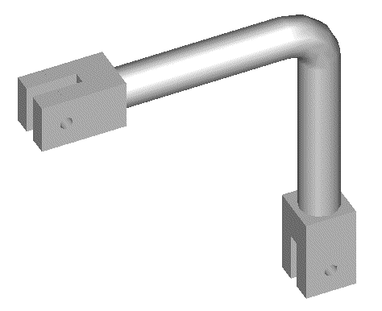
Figure 1. Figures should be centered and followed by a numbered caption.

The following is an example of the equations.
(1)
¹Title, Affiliation, Location (name@email.com)
² Title, Affiliation, Location
³ Title, Affiliation, Location

Table 1 Tables should be centered and preceded by a numbered caption.
 | P-1 | P-2 | P-3 | P-4 | P-5
D_{o Flank-Flank} | 2.384 | 2.393 | 2.408 | 2.424 | 2.378
t - Flank | 0.196 | 0.223 | 0.224 | 0.224 | 0.207
t– Flank | 0.241 | 0.228 | 0.226 | 0.225 | 0.233
D_{o Intra-Extra} | 2.358 | 2.270 | 2.274 | 2.303 | 2.379
t - Intrados | 0.243 | 0.281 | 0.293 | 0.282 | 0.200
t - Extrados | 0.204 | 0.199 | 0.202 | 0.205 | 0.217
Abstracts have to be in black and white. Therefore, all items including figures must not have any colored elements. They may not reproduce well in case of printing.

Conclusions
An abstract may include references. In-text references should consist of last names of authors and the year, for example, Hughes and Allik (1969), Cook et al. (2002), Chang (1987), UBC (1988), and Frater and Packer (1992). Entries in “References” section should be single-spaced (not 1.5 lines, as elsewhere), listed alphabetically by the last name of the first author, or by title – if author is not available. Each entry should consist of the following (adapted as necessary): names of authors (last name first), year, paper or publication title, journal or book title, publisher, journal volume and number, page numbers’ range.

References
Chang, T. C. (1987). Networking resource allocation using an expert system with fuzzy logic reasoning, PhD thesis, University of California at Berkeley, CA.
Cook, R. D., Malkus, D. S., Plesha, M. E. and Witt, R. J. (2002). Concepts and Applications of Finite Element Analysis, 4th ed., John Wiley & Sons.
Frater, G. S. and Packer, J. A. (1992). “Weldment design for RHS truss connections. II: Experimentation,” J. Structural Engineering, ASCE, 118(10), 2804-2820.
Hughes, T. J. R. and Allik, H. (1969). “Finite Elements for Compressible and Incompressible Continua,” Proc., Symposium on Application of Finite Element Methods in Civil Engineering, ASCE, Nashville, TN, 27-62.
International Conference of Building Officials. (1988). Uniform building code. Whittier, CA.

